**JOBSHEET 2**

**FRAMEWORK BASED PROGRAMMING**



By:

DAFFA USMAN

NIM : 1941720084

**PROGRAM STUDI D-IV TEKNIK INFORMATIKA**

**JURUSAN TEKNOLOGI INFORMASI**

**POLITEKNIK NEGERI MALANG**

**2022**

Experiment A

Node js installation.

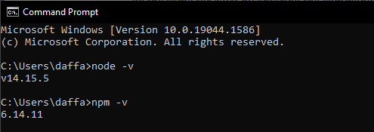

I already have node js installed before, so I only have to verify it.

Experiment B

Adding react to the website.

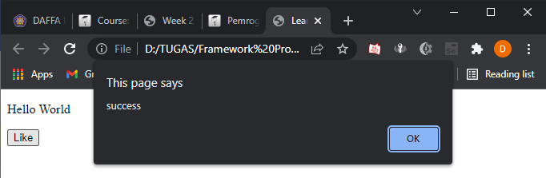

Experiment C

React app Installation

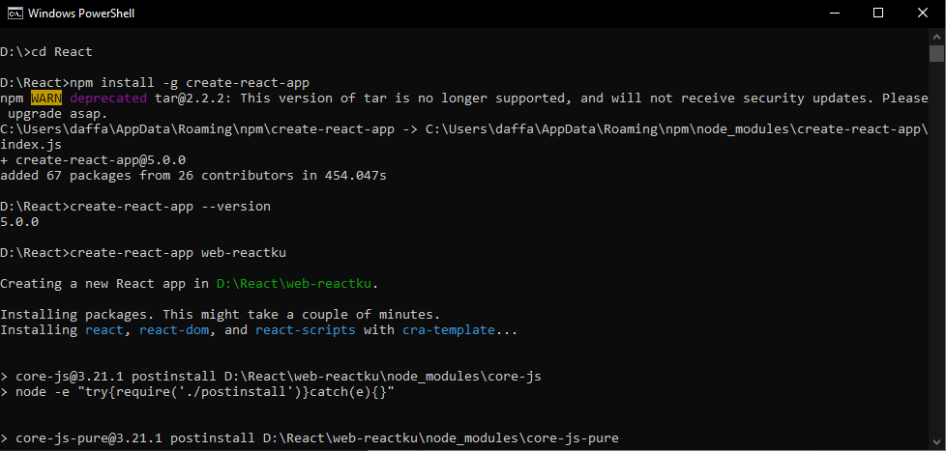

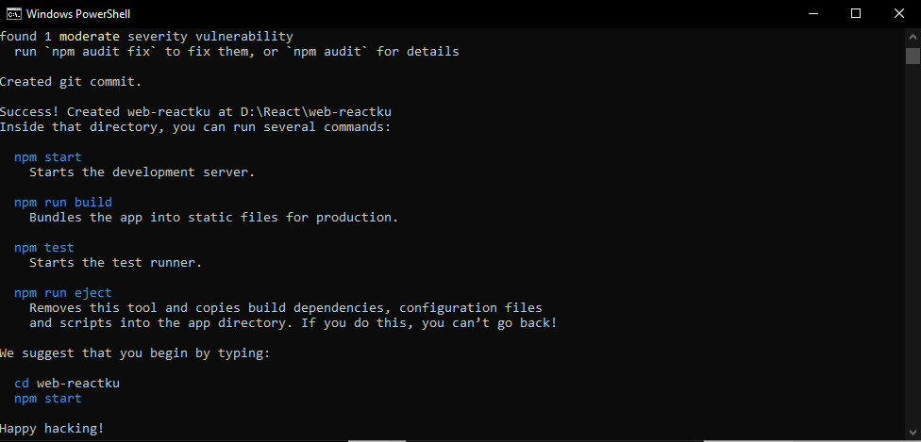

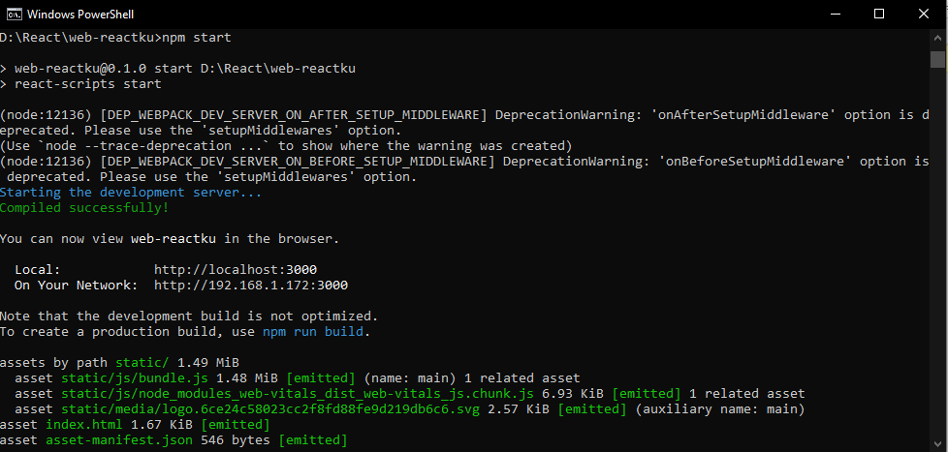

Result :

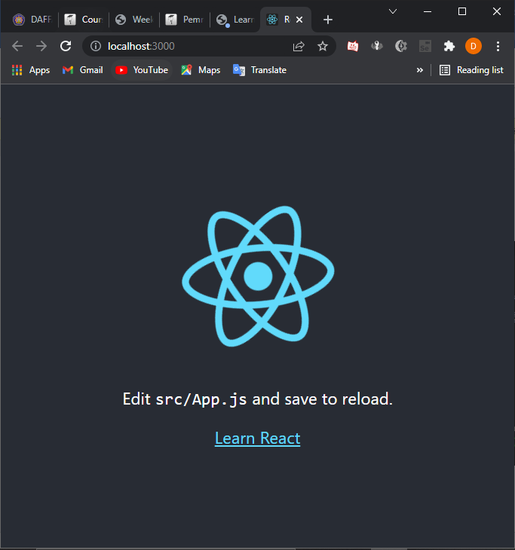

Experiment E

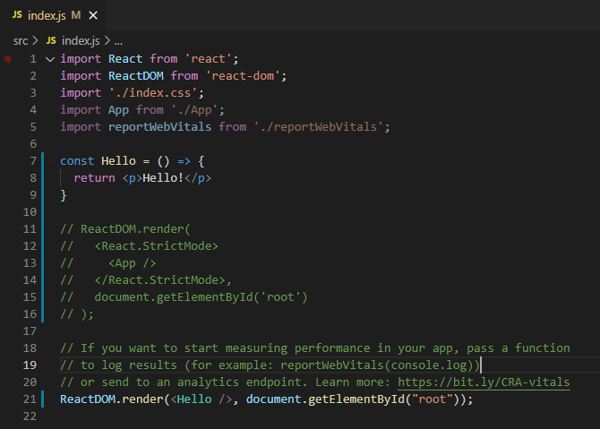

Result:

